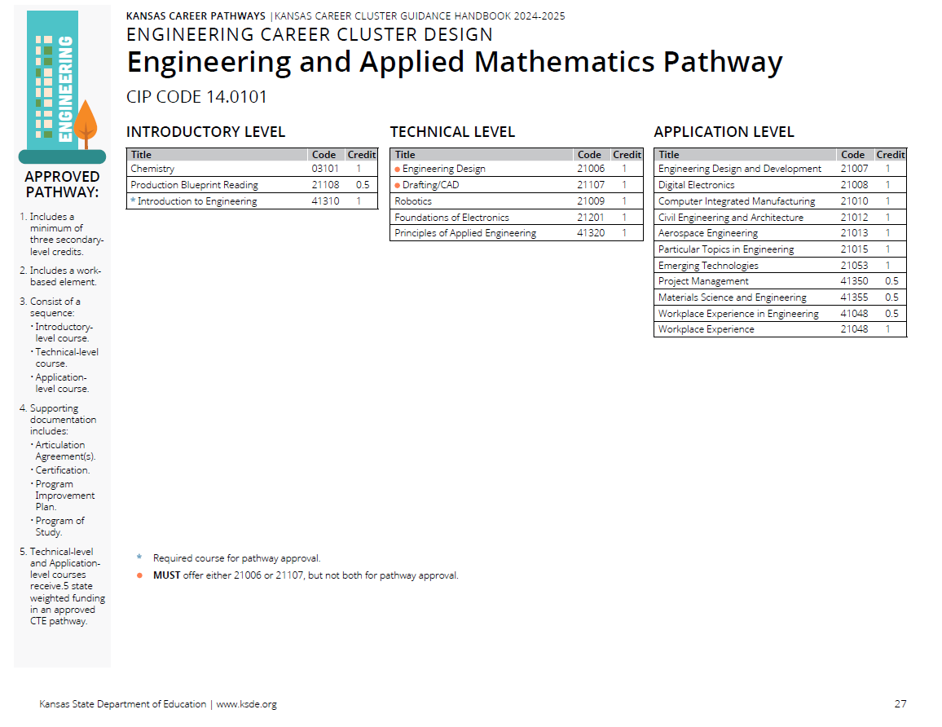

Prior to the Cluster Review

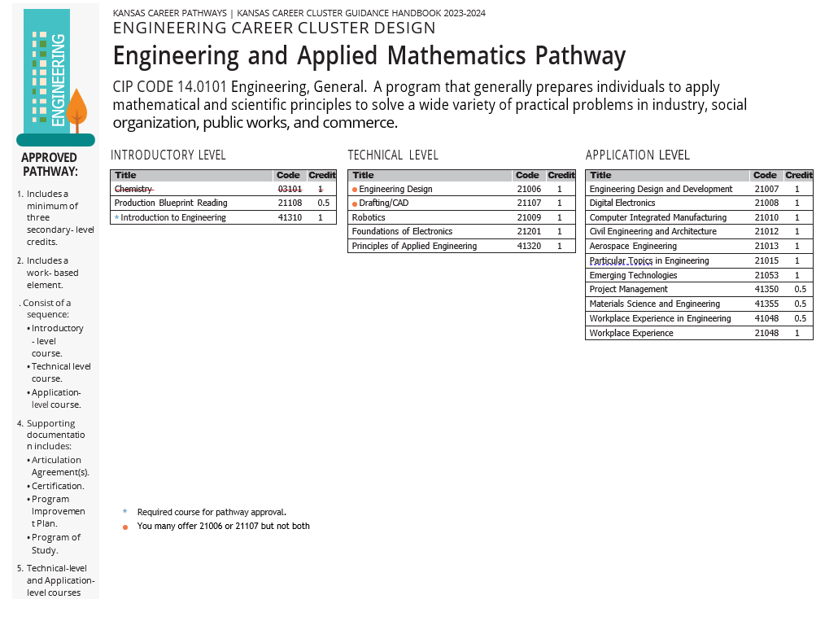
Recommendations Following Cluster Review

Pathway Recommendations Summary:

No Recommend Changes CTE Course Competencies and Indicators (ksde.org)

- Courses with No Changes
  - 21108 Production Blueprint Reading
  - 21013 Aerospace Engineering

Courses Reviewed with Recommended Changes

- Courses being removed from the pathway.
  - 03101 Chemistry

- Courses with updated competencies and benchmarks
  - 41310 Introduction to Engineering
  - 21006 Engineering Design
  - 21107 Drafting/CAD
  - 21009 Robotics I
  - 21201 Foundations of Electronics
  - 41320 Principles of Applied Engineering
  - 21007 Engineering Design and Development
  - 21008 Digital Electronics
  - 21010 Computer Integrated Manufacturing
  - 21012 Civil Engineering and Architecture
  - 21015 Particular Topics in Engineering
  - 21053 Emerging Technologies
  - 41350 Project Management
  - 41355 Materials Science and Engineering
  - 21048 Workplace Experience
  - 41048 Workplace Experience in Engineering

